**Program 2:**

Design and implement C/C++ Program to find Minimum Cost Spanning Tree of a given connected undirected graph using Prim’s algorithm.

**Algorithm:**

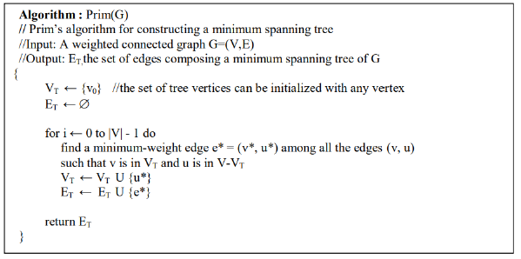

**Code:**

#include<stdio.h>

int ne=1,min_cost=0;

void main()

{

int n,i,j,min,cost[20][20],a,u,b,v,source,visited[20];

printf("Enter the number of nodes: ");

scanf("%d",&n);

printf("Enter the cost matrix:\n");

for(i=1;i<=n;i++)

{

for(j=1;j<=n;j++)

{

scanf("%d",&cost[i][j]);

}

}

for(i=1;i<=n;i++)

visited[i]=0;

printf("Enter the root node: ");

scanf("%d",&source);

visited[source]=1;

printf("\n Minimum cost spanning tree is\n");

while(ne<n)

{

min=999;

for(i=1;i<=n;i++)

{

for(j=1;j<=n;j++)

{

if(cost[i][j]<min)

if(visited[i]==0)

continue;

else

{

min=cost[i][j];

a=u=i;

b=v=j;

}

}

}

if(visited[u]==0||visited[v]==0)

{

printf("\nEdge %d\t(%d->%d)=%d\n",ne++,a,b,min);

min_cost=min_cost+min;

visited[b]=1;

}

cost[a][b]=cost[b][a]=999;

}

printf("\nMinimum cost=%d\n",min_cost);

}

**Output:**

